**Traffic Accidents Data Analysis using SPSS**

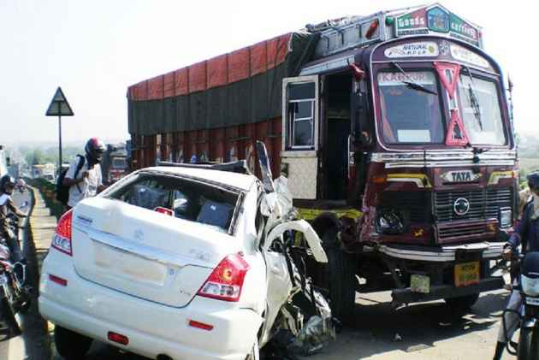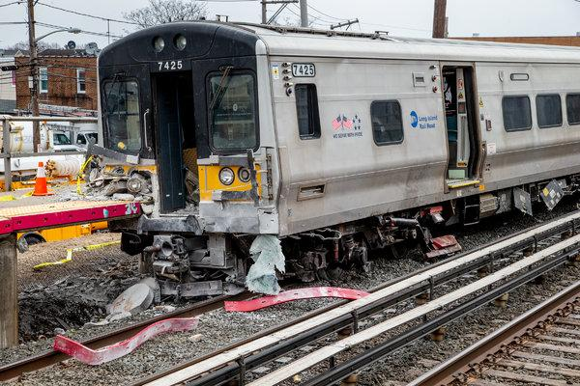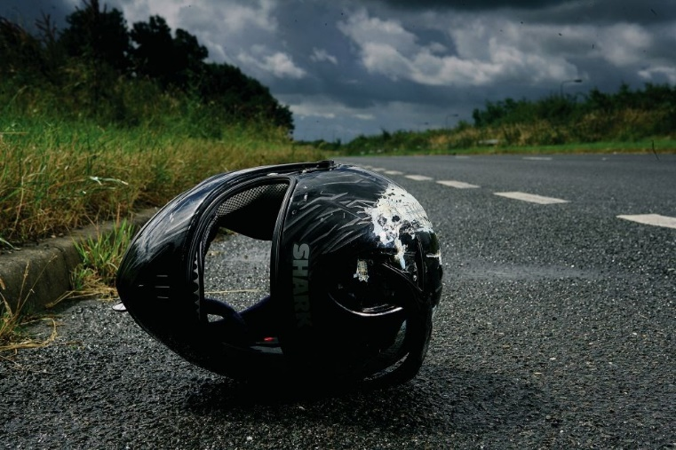

**Presented By**

Shankey Gupta

CSE-BAO

**Introduction to SPSS**

**SPSS** means “**S**tatistical **P**ackage for the **S**ocial **S**ciences” and was first launched in 1968. Since SPSS was acquired by IBM in 2009, it's officially known as IBM SPSS Statistics but most users still just refer to it as “SPSS”.

SPSS is software for **editing and analyzing all sorts of data**. These data may come from basically any source: scientific research, a customer database, Google Analytics or even the server log files of a website. SPSS can open all file formats that are commonly used for structured data such as

* spreadsheets from MS Excel or [OpenOffice](https://www.openoffice.org/);
* plain text files (.txt or .csv);
* relational (SQL) databases;
* Stata and SAS.

**Traffic Accidents Data**

* This data contains various types of traffic accidents’ information in different states.
* It has total 12 attributes.
* Data file also contains information related to time and year of accidents.
* This data is of timeline between 2001 to 2014.

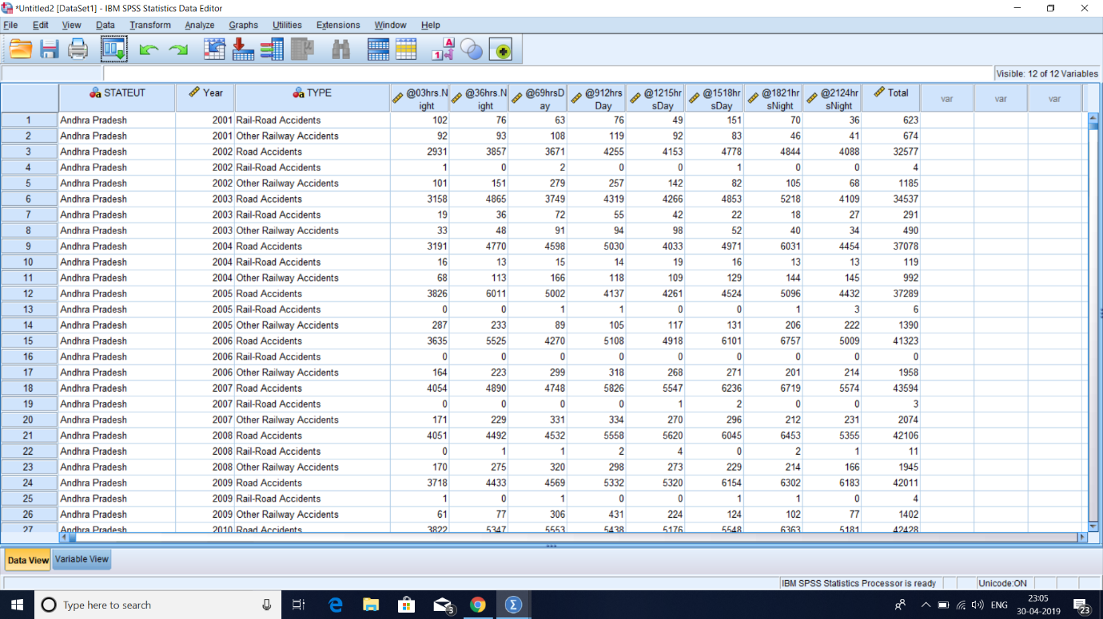

**Data Loading:**

* Data Loading process is shown into the following picures.
* 2nd picture shows attributes of data file.
* The 3rd picture shows the terminal of SPSS.

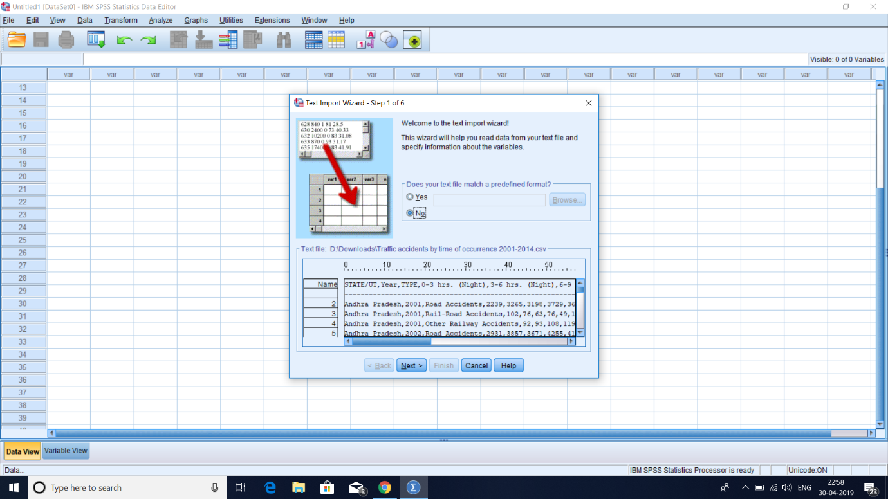

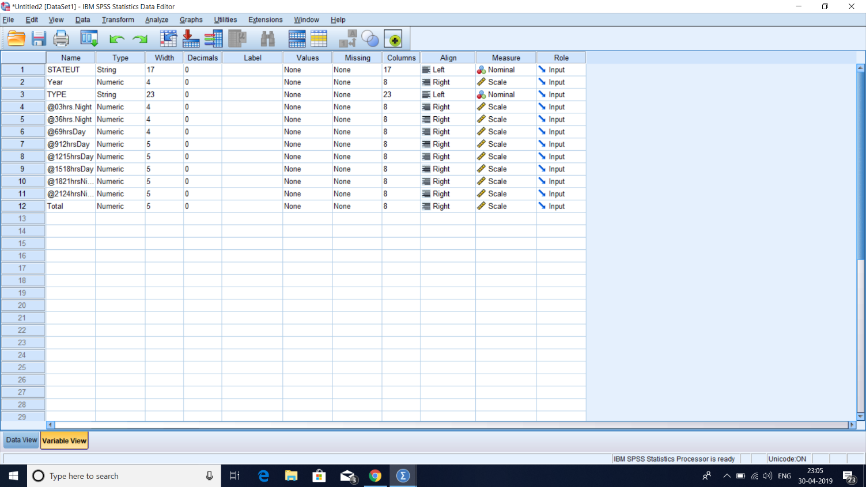

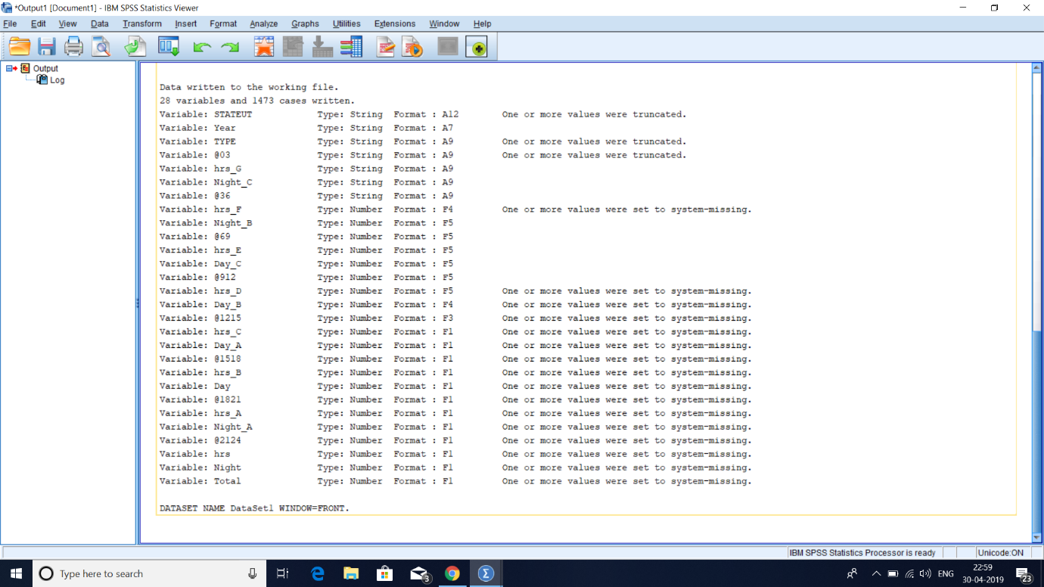

**Previous Analysis:**

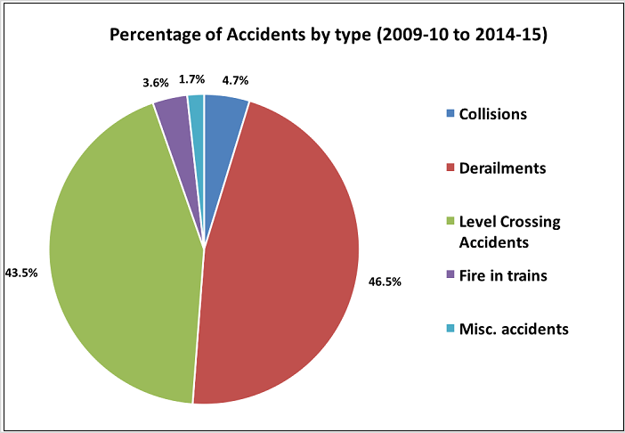

**Data Analysis:**

1. 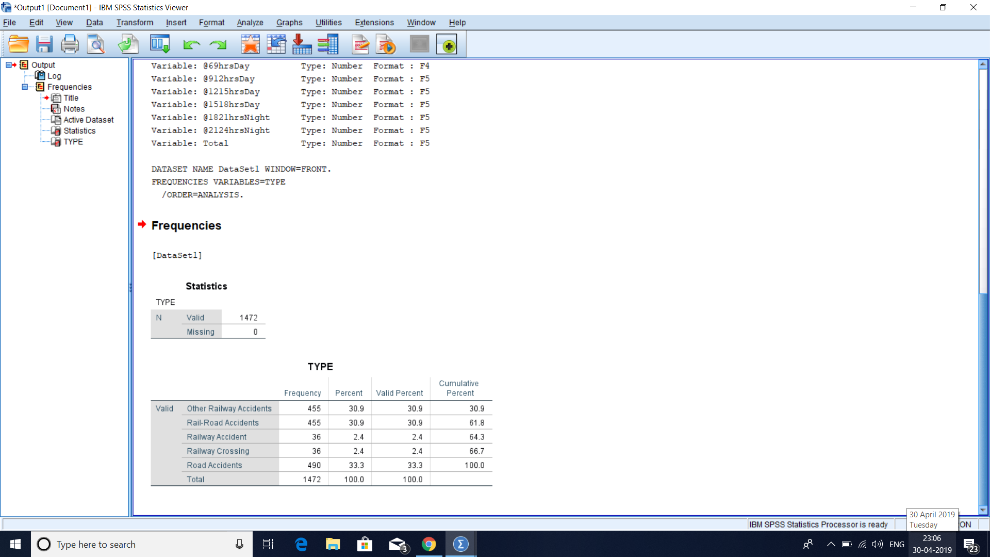We find out about the frequency and percentage of various types of traffic accidents.
2. Frequency of various types of traffic accidents is shown using Bar Chart.

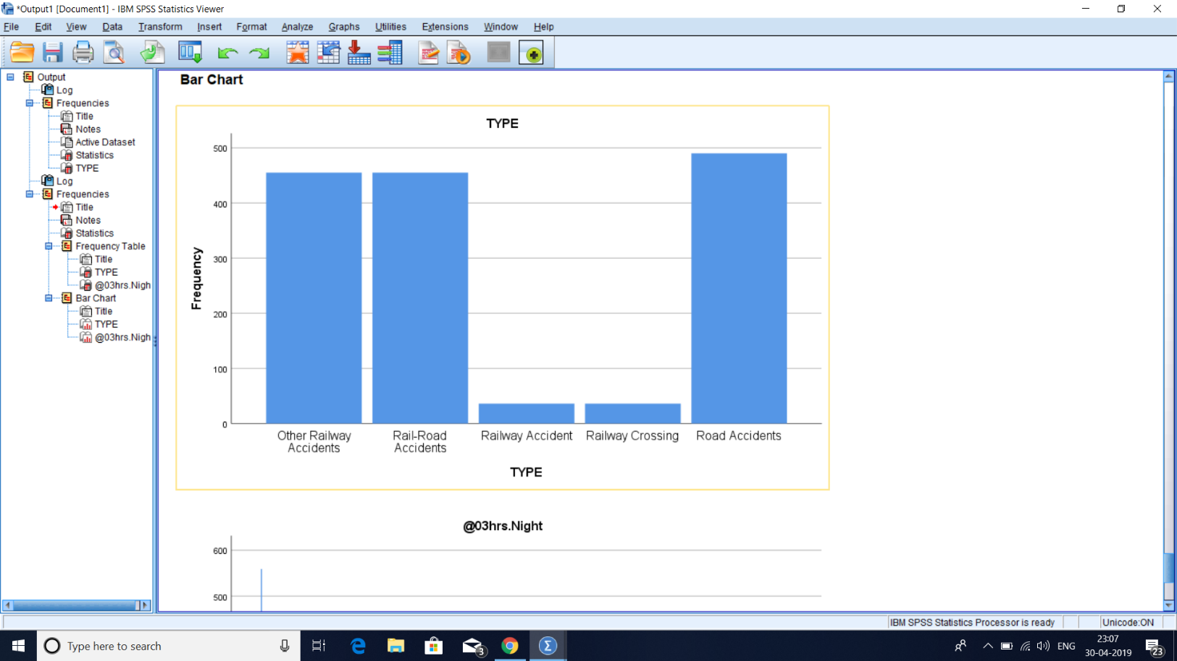

1. Various types of traffic accidents are shown using Pie Chart.

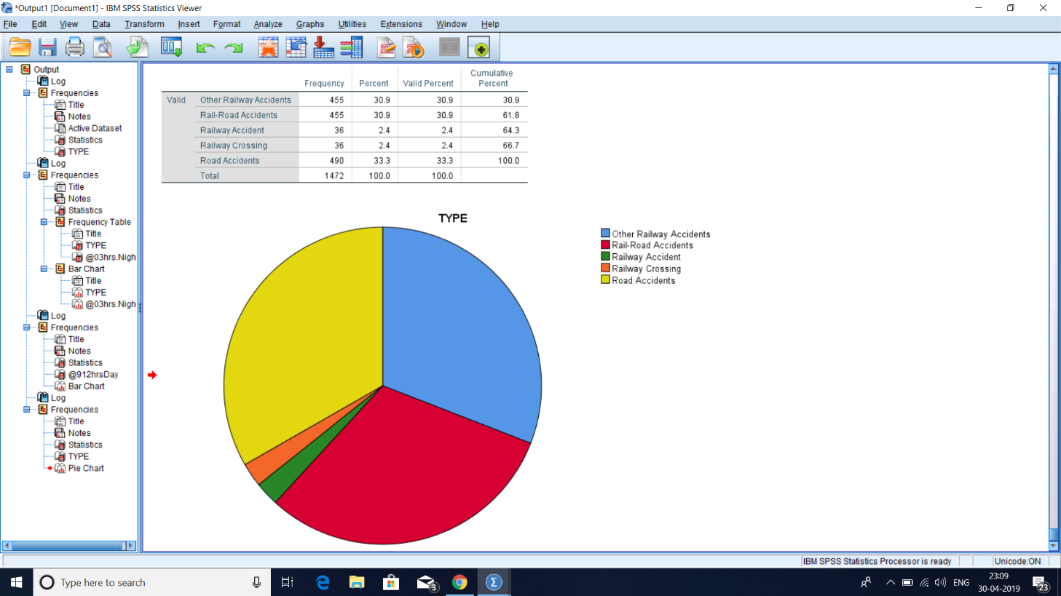

1. Year wise frequency of accidents is shown using Histogram.

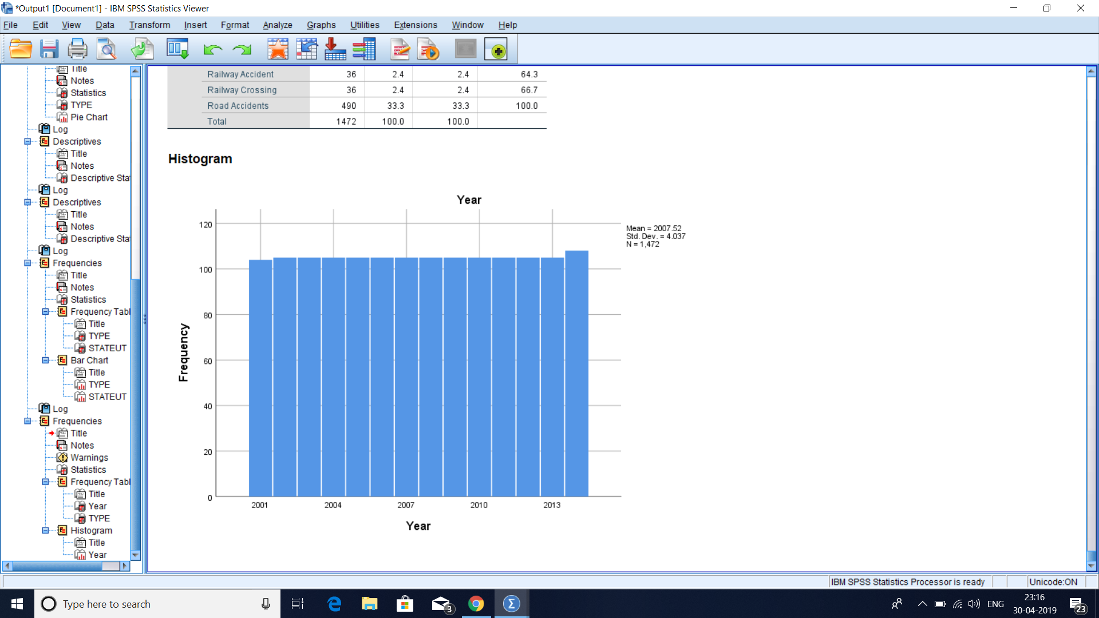

1. Descriptive Statistics of Year wise data with respect to 3Hrs night.

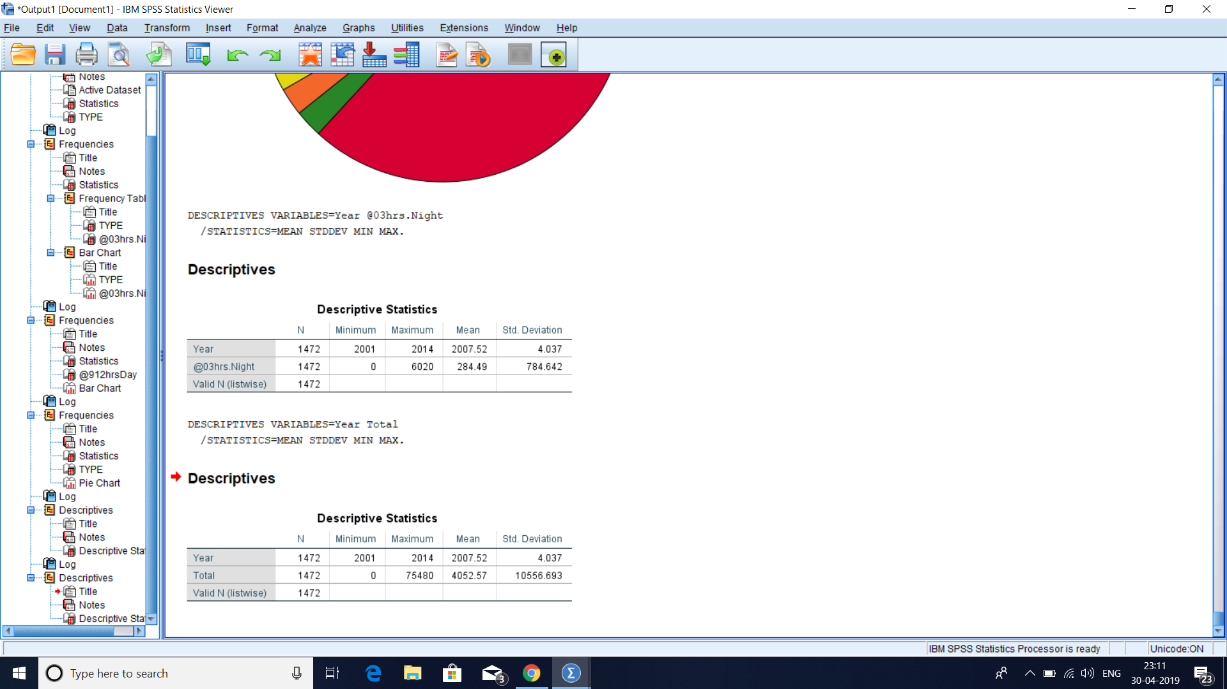

1. Descriptive Statistics of Year wise data with respect to ‘Total’ attribute.



1. State wise frequency of accidents is shown using bar graph.

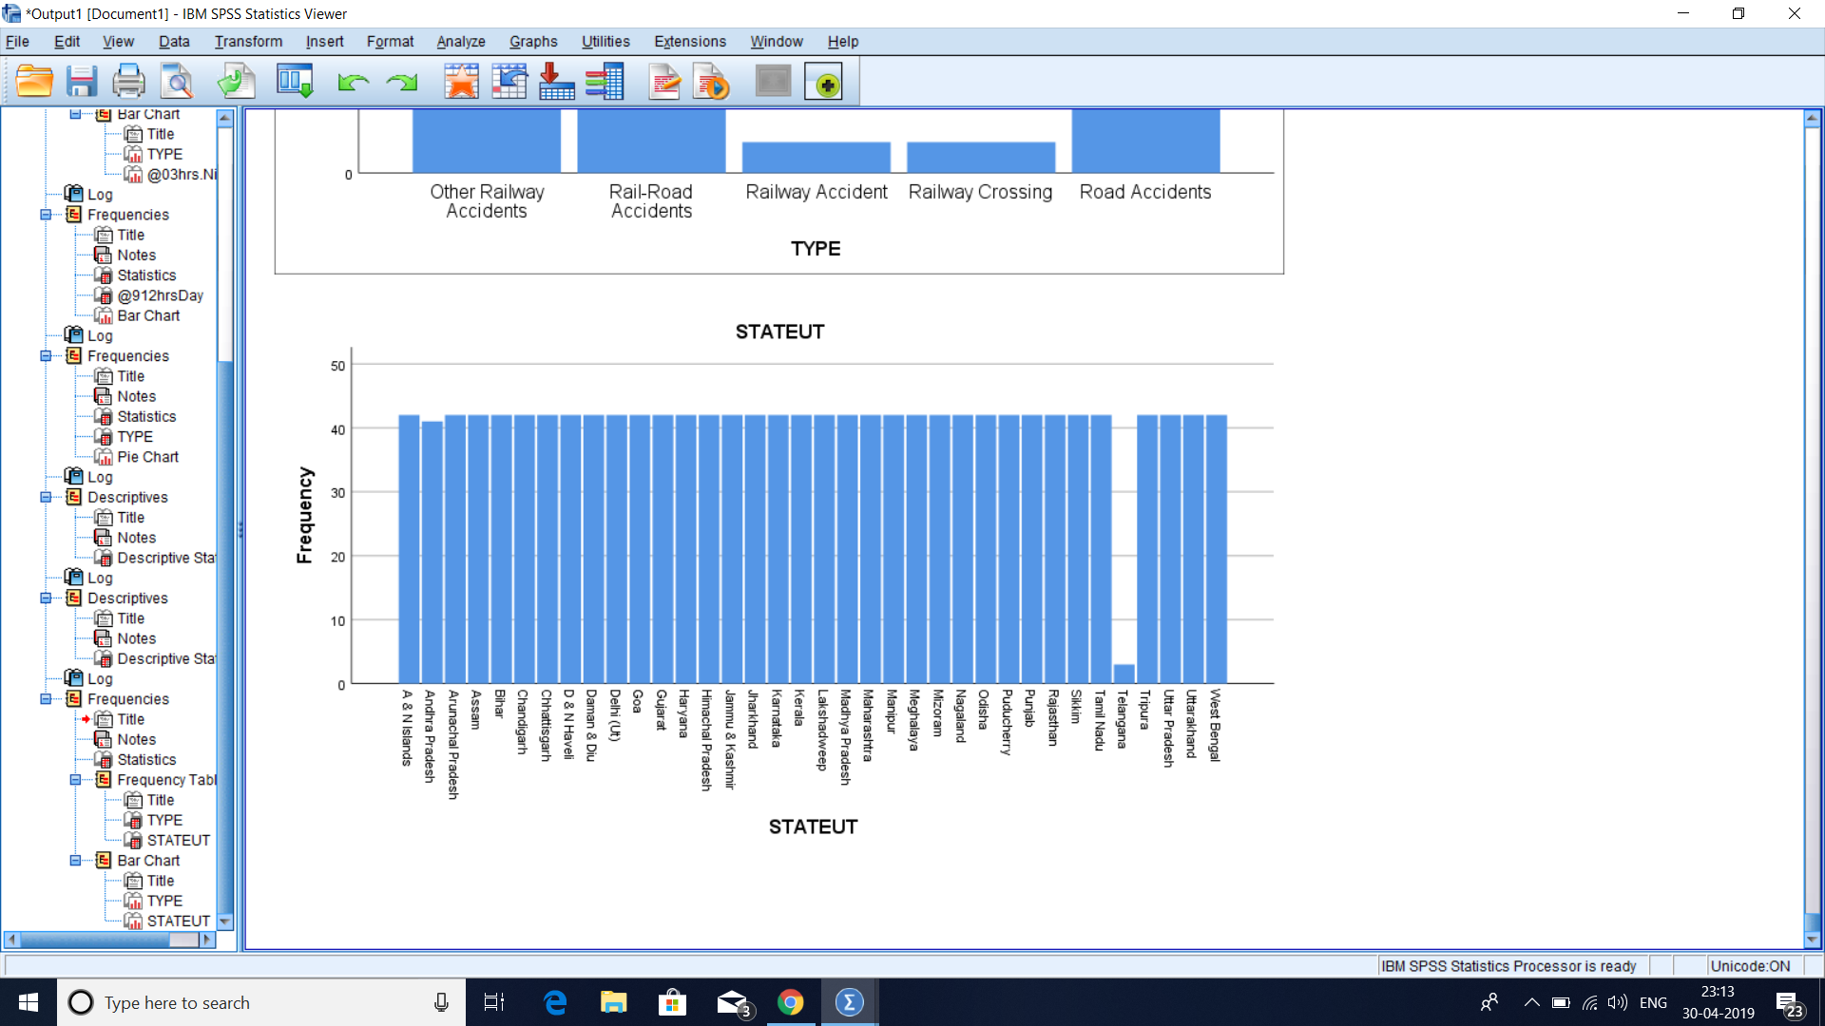

**Conclusions:**

* Road accidents have highest frequency yet highest percent. So, this is the main area of concern because it has highest priority.
* Rail-Road accidents and other railway accidents are second priority area of concern. We need to make plan to reduce them.
* From 2001 to 2014 accidents’ frequency is increasing.
* A & N Islands has the highest accident rates so it is main city area of concern.
* Telangana is the safest city because it has lowest accidents rate.